-Blog API report-

*Testing API Using Postman*

|  |  |
| --- | --- |
| Item | Link |
| Github Repository | [Blog-API-Testing](https://github.com/nejlaBelagosi/Blog-API-Testing) |
| Postman documentation | [Blog API](https://documenter.getpostman.com/view/48284099/2sB3HopKqH) |
| JSONplaceholder | [API Sample](https://jsonplaceholder.typicode.com/guide) |

Contents

INTRODUCTION 1

COLLECTION DESCRIPTION 1

API OVERVIEW 3

TESTS 4

NOTES 8

Popis priloga 9

# INTRODUCTION

This project demonstrates testing of the Blog API using Postman and JSONplaceholder API sample.

The goal is to show how to test API endpoints, validate responses, and generate reports and documentation.

# COLLECTION DESCRIPTION

Collection name: Blog API

Environment name: Blog API Testing

Collection structure:

Blog API /

Positive Endpoints /

User API Testing

Posts API Testing

Comments API Testing

Negative Endpoints /

User API Testing

Posts API Testing

Comments API Testing

All variables:

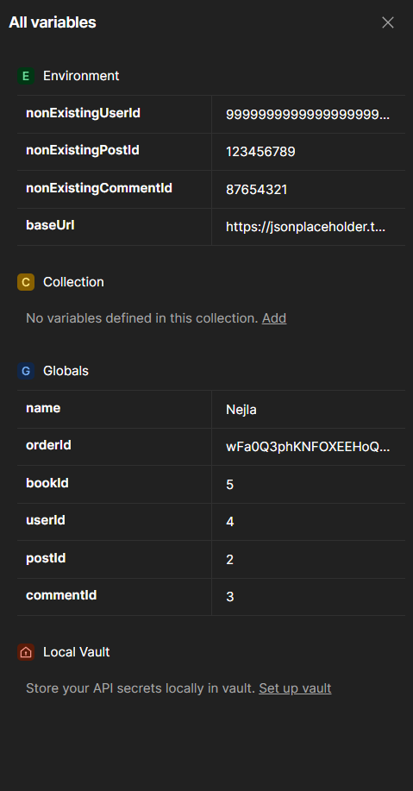

Figure All variables

# API OVERVIEW

{{baseURL}} = <https://jsonplaceholder.typicode.com>

|  |  |  |
| --- | --- | --- |
| Endpoint | Method | Description |
| /users | GET | Retrieves all blog users. |
| /users/:userId | GET | Retrieves a single blog user. |
| /users | POST | Creates a new user. |
| /users/:userId | PUT | Updates an existing user. |
| /users/:userId | PATCH | Updates one or more fields of an existing user. |
| /users/:userId | DELETE | Deletes a specific user. |
| /posts | GET | Retrieves all blog posts. |
| /posts/:postId | GET | Retrieves a single post. |
| /posts | POST | Creates a new post. |
| /posts/:postId | PUT | Updates an existing post. |
| /posts/:postId | PATCH | Updates one or more fields of an existing post. |
| /posts/:postId | DELETE | Deletes a specific post. |
| /comments | GET | Retrieves all blog comments. |
| /comments/:commentId | GET | Retrieves a single comment. |
| /comments | POST | Creates a new comment. |
| /comments/:commetId | PUT | Updates an existing comment. |
| /comments/:commetId | PATCH | Updates one or more fields of an existing comment. |
| /comments/:commetId | DELETE | Deletes a specific comment. |

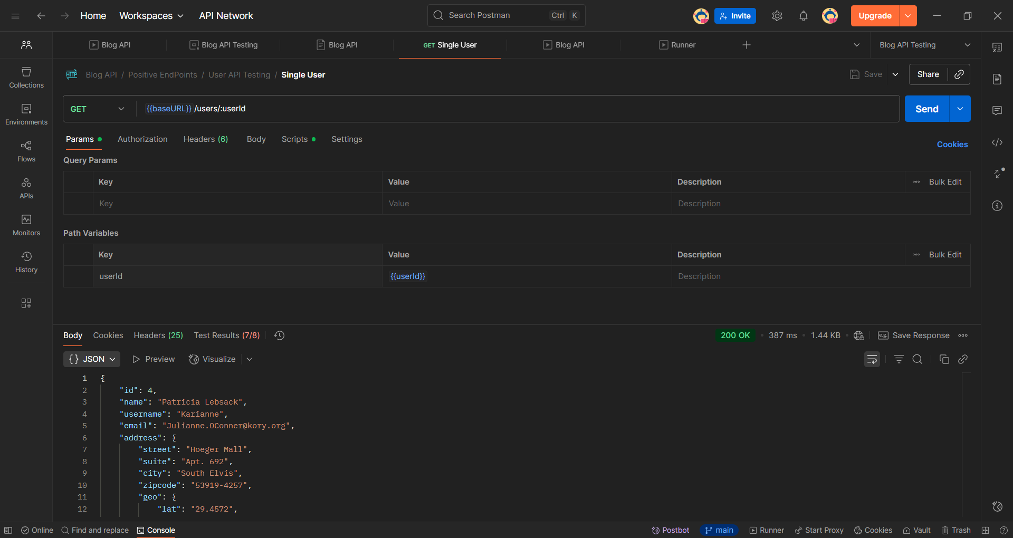

Figure Example of a request and response

# TESTS

Script example for Positive Endpoint -> DEL Delete User

pm.test("Status code is 200", *function* () {

    pm.response.to.have.status(200);

});

//checks response time

pm.test("Response time is less than 200ms", *function* () {

    pm.expect(pm.response.responseTime).to.be.below(200);

});

//checks if API URL Endpoint is valid

pm.test("URL Endpoint is valid", *function* () {

    pm.expect(pm.request.url.toString()).to.eql(`https://jsonplaceholder.typicode.com/users/${pm.globals.get("userId")}`);

});

//checks header content type

pm.test("Content-Type is application/json", *function* () {

    pm.expect(pm.response.headers.get("Content-Type")).to.include("application/json");

});

//checks if user is really deleted

pm.test("User is deleted", *function* () {

*let* responseData = pm.response.json() ? pm.response.json() : {};

    pm.expect(*Object*.keys(responseData).length).to.be.at.most(1);

});

Script example for Negative Endpoint for DEL Delete User:

// Post-response test script for DELETE /users/:userId

// Check if the API is JSONPlaceholder by inspecting the baseURL environment variable

*const* isJSONPlaceholder = pm.environment.get("baseURL") && pm.environment.get("baseURL").includes("jsonplaceholder");

// Test for deleting a non-existing user

if (isJSONPlaceholder) {

    // JSONPlaceholder returns 200 OK even if the user does not exist

    pm.test("Delete non-existing user in JSONPlaceholder returns 200 OK", *function* () {

        pm.expect(pm.response.code).to.eql(200);

        // Optionally, check response body structure if needed

    });

} else {

    // For other APIs, deleting a non-existing user should return 404 Not Found

    pm.test("Delete non-existing user returns 404 Not Found", *function* () {

        pm.expect(pm.response.code).to.eql(404);

        // Check if response body contains an error message or structure

        try {

*var* jsonData = pm.response.json();

            pm.expect(jsonData).to.be.an('object');

            pm.expect(jsonData.error || jsonData.message).to.exist;

        } catch (e) {

            // Response is not JSON or no error message present

            pm.test("Response body is valid JSON with error message", *function* () {

                pm.expect.fail("Response body is not valid JSON or missing error message");

            });

        }

    });

}

// Test for idempotency: deleting the same user twice should yield consistent error responses

pm.test("Idempotency test: deleting the same user twice returns consistent error responses", *function* () {

    // We assume the userId variable is set in the environment or collection

*const* userId = pm.variables.get("userId") || "";

    if (!userId) {

        pm.test.skip("No userId provided for idempotency test");

        return;

    }

    // Send the DELETE request again for the same userId

    pm.sendRequest({

        url: pm.request.url.toString(),

        method: 'DELETE',

        header: pm.request.headers.toObject(),

        body: pm.request.body ? pm.request.body.toString() : undefined

    }, *function* (*err*, *res*) {

        pm.test("Second delete request returns expected status code", *function* () {

            if (isJSONPlaceholder) {

                pm.expect(res.code).to.eql(200);

            } else {

                pm.expect(res.code).to.eql(404);

            }

        });

        if (!isJSONPlaceholder) {

            pm.test("Second delete response contains error message", *function* () {

                try {

*var* jsonData = res.json();

                    pm.expect(jsonData.error || jsonData.message).to.exist;

                } catch (e) {

                    pm.expect.fail("Second delete response body is not valid JSON or missing error message");

                }

            });

        }

    });

});

// Suggested tests for other invalid user IDs

// These tests can be added as separate requests or as part of a collection run

// Examples include malformed userId (e.g., special characters), empty userId, or null

// For demonstration, here is a test for empty userId in this response script context

pm.test("Delete user with empty userId returns error", *function* () {

    // This test assumes the request was sent with an empty userId path variable

    pm.expect(pm.response.code).to.be.oneOf([400, 404]); // Depending on API design

});

// End of post-response test script

|  |  |  |  |  |  |
| --- | --- | --- | --- | --- | --- |
| Source | Environment | Iterations | Duration [ms] | All tests | Avg/ Resp. Time [ms] |
| Runner | Blog API Testing | 1 | 21s671 | 1465 | 165 |

|  |  |  |
| --- | --- | --- |
| Passed | Failed | Skipped |
| 1426 | 39 | 0 |

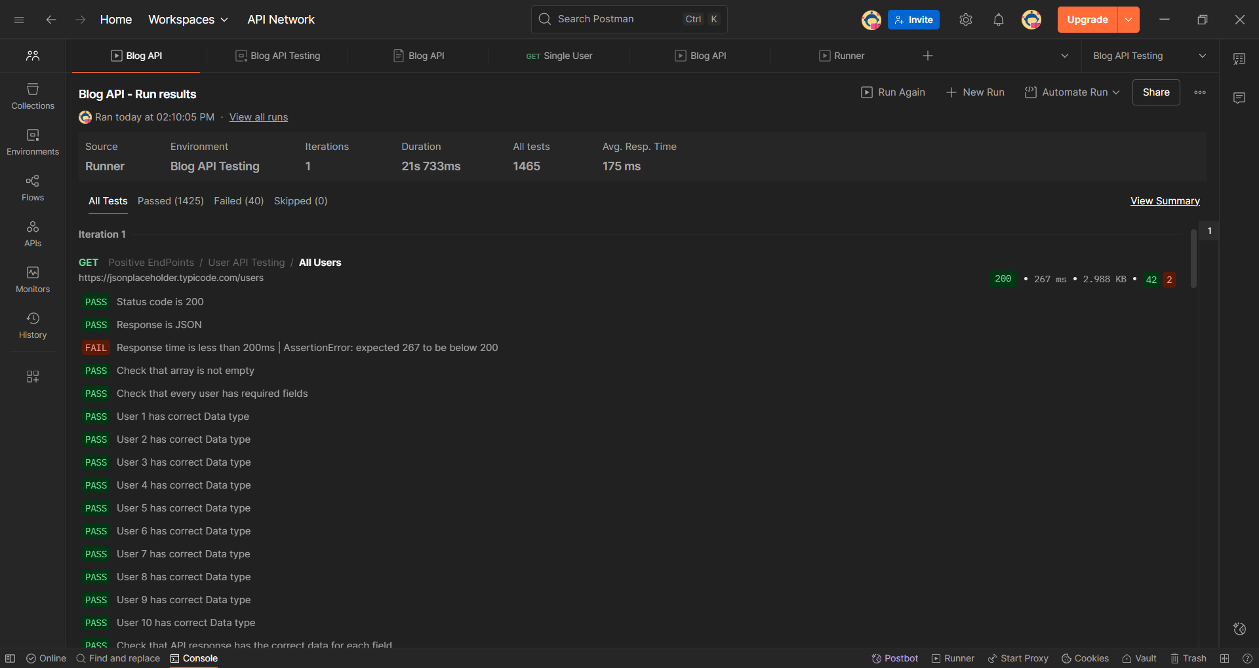

Figure Functional Test Report

|  |  |  |
| --- | --- | --- |
| Load Profile | Number of Virtual Users | Test duration [min] |
| Fixed | 50 | 2 |

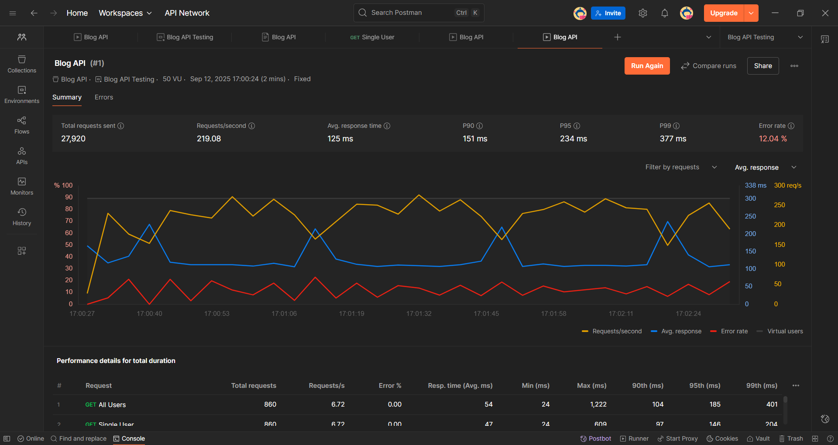

Figure Performance Test report

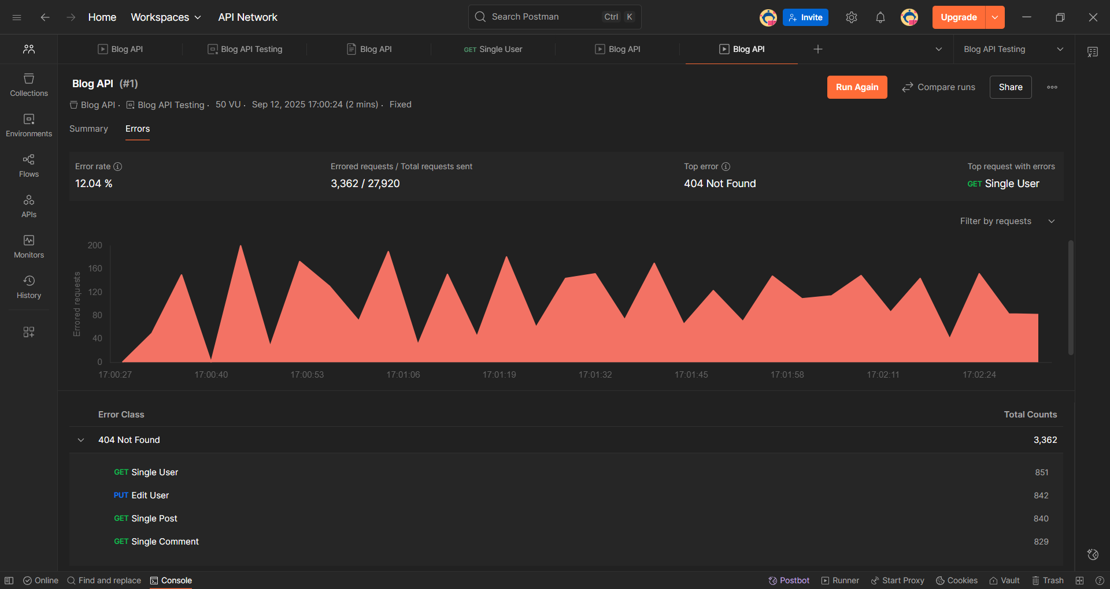

Figure Performance Testing Errors summary

# NOTES

*JSONplaceholder is a mock API for testing and learning purpose.*

*Some endpoints don’t behave exactly like a real API (e.g., POST, PUT, DELETE may return success but don’t actually modify data).*

*Certain endpoints may sometimes fail or return unexpected results.*

*This is normal because the service is simulated and not persistent.*

# Popis priloga

Figure 1 All variables 2

Figure 2 Example of a request and response 3

Figure 3 Functional Test Report 7

Figure 4 Performance Test report 7

Figure 5 Performance Testing Errors summary 8